Week 4:
Plan and Estimate Assignment
Caleb Cox
Cheryl (Shuang) Smith
Sharon Rodriguez Pabon
Samed Ganibegovic
SWDV 650 - SOFTWARE DEVELOPMENT PROCESS AND PROCEDURES
Maryville University
Professor William Shirley
May 30, 2025

User Story #1: Local Community Reviewer (Current User - MFA)
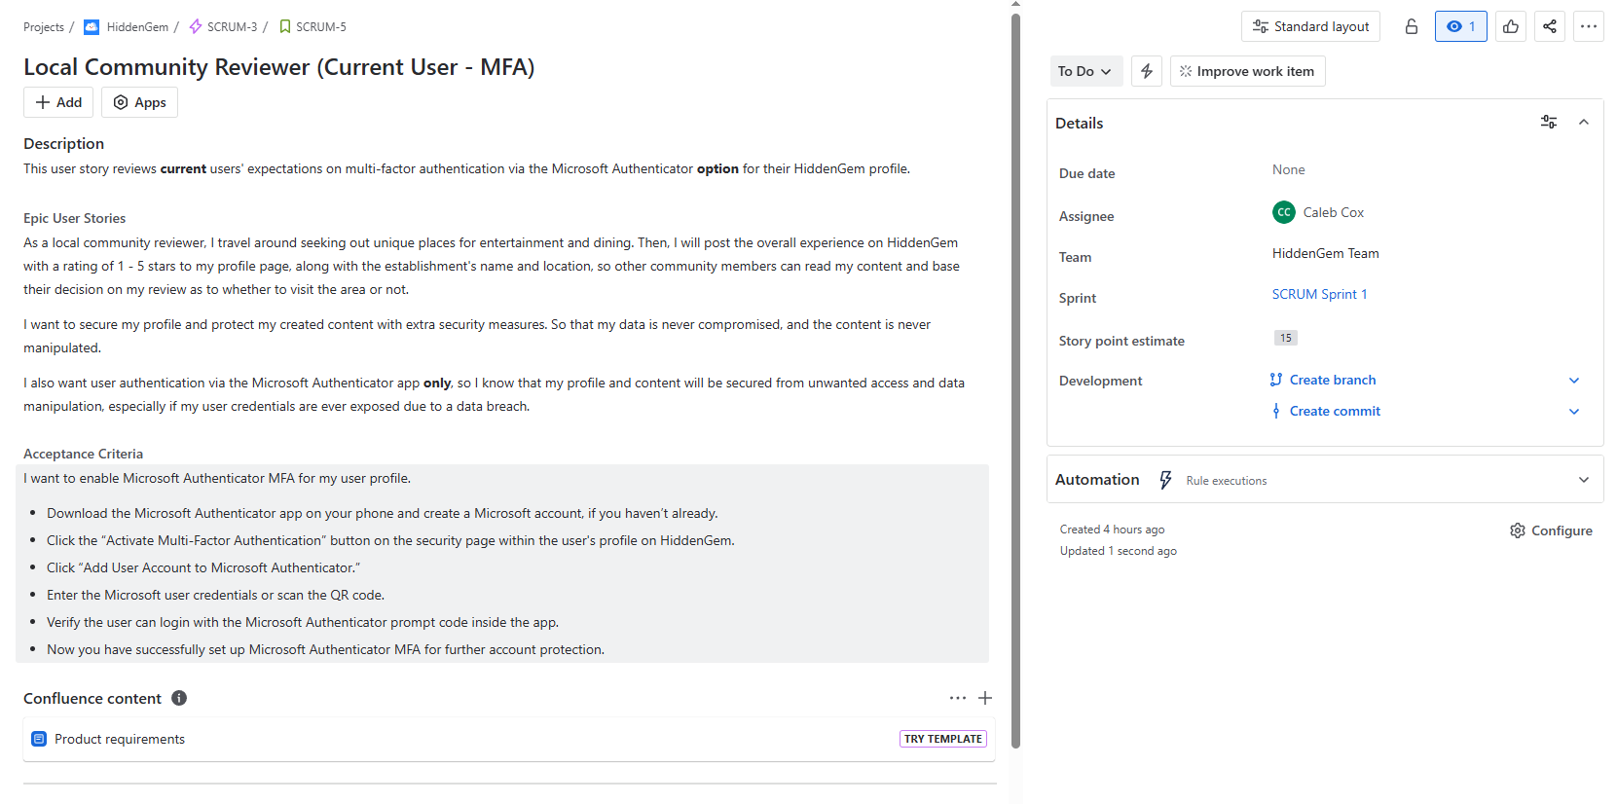

User Story #1 Tasks: Local Community Reviewer (Current User - MFA)
